Microsoft Intune
Entra ID Group Naming Convention
Version 1.1 | May 2026

1. Summary
This document sets out the naming convention for Microsoft Entra ID security groups used in Microsoft Intune. It covers the production tenant only. Dev environments are out of scope here.
The goal is simple: group names that are readable at a glance, consistent as the environment grows, and don't need re-explaining every time someone new joins the team.
The convention is built around a ring deployment model. Policy types that benefit from staged testing have an explicit ring segment in their group name. Types that get assigned directly, like Conditional Access exclusions or Autopilot profiles, use a shorter pattern without one.

2. Naming Convention Framework
Every group name follows one of two patterns, depending on whether the policy type uses the ring pipeline or not.

Ring-staged policies:
MDM-[PLATFORM]-[FUNCTION]-[RING]-[SCOPE]-[DETAIL]

Outside pipeline policies:
MDM-[PLATFORM]-[FUNCTION]-[SCOPE]-[DETAIL]

The ring segment only appears when it means something. For policies assigned directly, it simply isn't there. No placeholders, no filler values.

Example (ring-staged):
MDM-WIN-CFG-RNG1-D-SecurityBaseline

2.1 Segment Reference

Platform
Code | Platform
WIN | Windows
IOS | iOS / iPadOS
MACOS | macOS
AND | Android
W365 | Windows 365 (Cloud PC)
ALL | Cross-platform / platform-agnostic

Function
Code | Intune Use Case | Ring-staged
CA | Conditional Access policy assignment | No (outside pipeline)
CFG | Settings Catalogue and device configuration profiles | Yes
APP | App deployment: required, available, or uninstall | Yes
EPM | Endpoint Privilege Management elevation policies | Yes
ACB | App Control for Business allow/deny policies | Yes
AP | Autopilot deployment profile assignment | No (outside pipeline)
PP | Windows 365 provisioning policies | No (outside pipeline)
ESP | Enrolment Status Profile assignment | No (use filters)
RMD | Remediation scripts | Yes
UPDATE | Windows and iOS update rings / staged rollouts | Yes

Ring
Ring values define where a group sits in the deployment pipeline. There are three.

Code | Meaning
RNG1 | Pilot group. Typically IT staff or early adopters.
RNG2 | Broad rollout group. A wider deployment before the final stage.
RNGALL | All members of the target group. Used only in scoped deployments where the final audience is a named sub-group, not the whole tenant.

For tenant-wide deployments, the progression is RNG1 then RNG2, then you assign directly to Microsoft's built-in groups. All Devices or All Users, depending on the scope. There's no RNGALL in that path, and no custom group is needed at the final stage.

Scope
Code | Meaning
D | Device group. The policy applies at the device level.
U | User group. The policy follows the user across devices.

3. Deployment Pipeline
The diagram below shows how the ring model works in practice. There are two possible end states: a scoped deployment that terminates at RNGALL, and a tenant-wide deployment that ends at Microsoft's built-in groups.
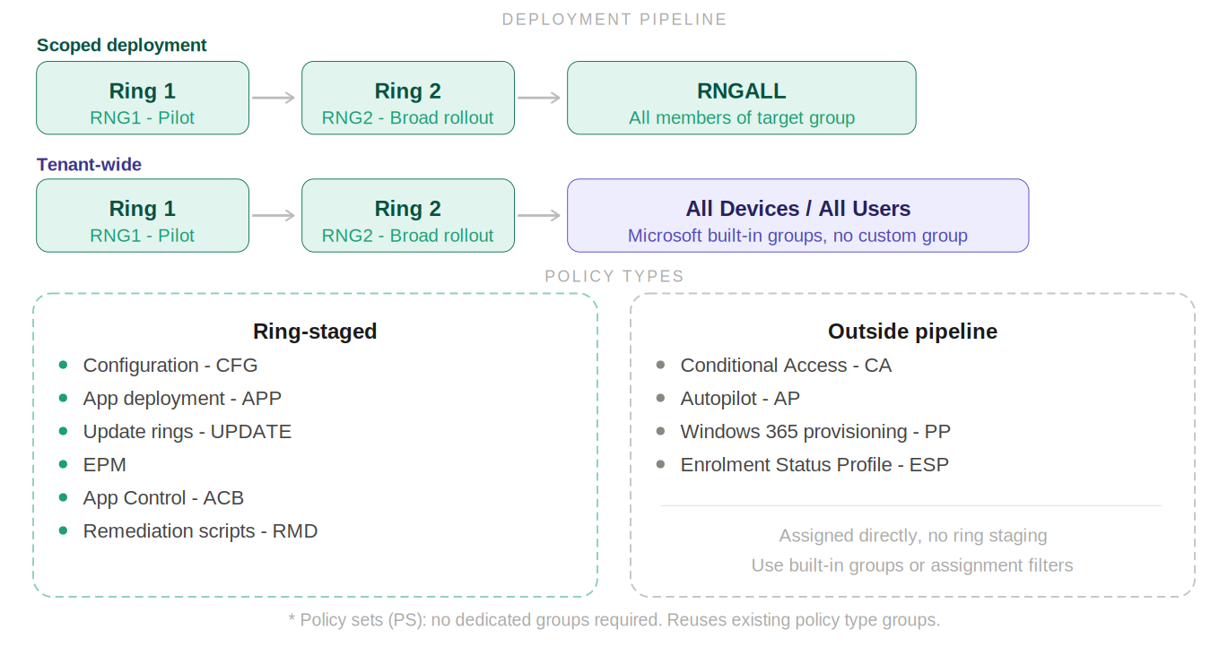
Figure 1. Ring deployment pipeline showing scoped and tenant-wide tracks, with policy types classified by staging requirement.

4. Convention by Intune Feature

4.1 Conditional Access
CA groups control who's included or excluded from Entra ID Conditional Access policies. They're almost always user-scoped since CA evaluates identity at sign-in time.
These sit outside the ring pipeline. You don't test CA exclusions in rings. They're assigned directly, and the shorter naming pattern reflects that.

Pattern:
MDM-ALL-CA-[D|U]-[Detail]

Example group name | Purpose
MDM-ALL-CA-U-Exclusions | Users excluded from all CA policies
MDM-ALL-CA-U-MFA-Exempt | Users exempt from MFA enforcement
MDM-WIN-CA-U-CompliantOnly | Windows users requiring a compliant device CA rule

4.2 Configuration Policies
Configuration groups target Settings Catalogue profiles, device restriction policies, and similar workloads. They can be device or user scoped depending on the setting type.
These go through rings. Start with RNG1 for your pilot devices, progress to RNG2 for the wider rollout. For tenant-wide policies, after RNG2 you assign to All Devices directly. For scoped policies, use RNGALL as the final ring.
Where a policy targets a specific OS version, use an Intune assignment filter rather than encoding the version in the group name. This keeps group names stable as OS versions change.

Pattern:
MDM-[PLATFORM]-CFG-[RNG1|RNG2|RNGALL]-[D|U]-[Detail]

Example group name | Purpose
MDM-WIN-CFG-RNG1-D-SecurityBaseline | Ring 1 pilot devices for Security Baseline policy
MDM-WIN-CFG-RNG2-D-SecurityBaseline | Ring 2 broad rollout for Security Baseline policy
MDM-WIN-CFG-RNGALL-D-PrinterPolicy | All target Windows devices for Printer policy (scoped)
MDM-ALL-CFG-RNG1-D-CloudPKI | Ring 1 devices for Cloud PKI certificate config
MDM-ALL-CFG-RNG2-D-CloudPKI | Ring 2 broad rollout for Cloud PKI config

4.3 Application Deployment
Application groups define who receives a deployed app, whether required, available, or targeted for uninstall. Use user groups where the app follows the user. Use device groups for system-level or shared-device deployments.

Pattern:
MDM-[PLATFORM]-APP-[RNG1|RNG2|RNGALL]-[D|U]-[AppName]

Example group name | Purpose
MDM-WIN-APP-RNG1-U-VisualStudio | Ring 1 users receiving Visual Studio (required)
MDM-WIN-APP-RNG2-U-VisualStudio | Ring 2 broad rollout for Visual Studio
MDM-WIN-APP-RNGALL-U-CompanyPortal | All target users receiving Company Portal (scoped)
MDM-IOS-APP-RNG1-U-EdgeBrowser | iOS Ring 1 pilot users for Edge browser
MDM-IOS-APP-RNG2-U-EdgeBrowser | iOS Ring 2 broad rollout for Edge browser

4.4 Endpoint Privilege Management (EPM)
EPM groups target devices or users for elevation policies. Device groups deploy the EPM policy itself. User groups are used where elevation is tied to a specific role or identity. OS doesn't need to be specified since EPM only applies to Windows.

Pattern:
MDM-EPM-[RNG1|RNG2|RNGALL]-[D|U]-[Detail]

Example group name | Purpose
MDM-EPM-RNG1-D-VisualStudio-Allow | Ring 1 devices permitted to elevate Visual Studio
MDM-EPM-RNG2-D-VisualStudio-Allow | Ring 2 devices permitted to elevate Visual Studio
MDM-EPM-RNGALL-D-VisualStudio-Allow | All target devices with Visual Studio elevation (scoped)
MDM-EPM-RNG1-D-Python-Allow | Ring 1 devices permitted to elevate Python installer
MDM-EPM-RNGALL-U-Developers | All developer users granted elevation privileges (scoped)

4.5 App Control for Business (ACB)
ACB groups determine which devices receive application control policies. Ring staging really matters here. Getting ACB wrong can block legitimate apps, so don't skip the pilot.

Pattern:
MDM-ACB-[RNG1|RNG2|RNGALL]-D-[Detail]

Example group name | Purpose
MDM-ACB-RNG1-D-CorpApps | Ring 1 devices for App Control corporate apps policy
MDM-ACB-RNG2-D-CorpApps | Ring 2 broad rollout for App Control corporate apps
MDM-ACB-RNGALL-D-CorpApps | All target devices for App Control (scoped deployment)
MDM-ACB-RNG1-D-FullAudit | Ring 1 devices in App Control audit mode

4.6 Autopilot Deployment Profiles
Autopilot groups are always device-scoped and assign deployment profiles. They sit outside the ring pipeline. You don't ring-stage Autopilot profiles. Maintain separate groups per profile type and assign them directly.

Pattern:
MDM-AP-D-[Detail]

Example group name | Purpose
MDM-AP-D-BISNET | Autopilot profile for BISNET devices
MDM-AP-D-Kiosk | Autopilot profile for kiosk / shared devices
MDM-AP-D-LenovoG13 | Autopilot profile for Lenovo G13 test enrolment

4.7 Provisioning Policies (Windows 365)
Provisioning Policy groups target users who will be provisioned a Windows 365 Cloud PC. The W365 platform tag makes the context clear without needing 'Cloud PC' or 'provisioning' in the detail segment.

Pattern:
MDM-W365-PP-U-[Detail]

Example group name | Purpose
MDM-W365-PP-U-CH8vCPU | Users receiving an 8vCPU Cloud PC provisioned in Switzerland
MDM-W365-PP-U-MX4vCPU | Users receiving a 4vCPU Cloud PC provisioned in Mexico

4.8 Update Rings
Update ring groups control staged rollouts of OS and driver updates. Both Windows and iOS update rings use the UPDATE function code.
Update rings typically don't use RNGALL. After RNG2, the final assignment goes to All Devices or All Users directly via Microsoft's built-in groups.

Pattern:
MDM-[PLATFORM]-UPDATE-[RNG1|RNG2]-[D|U]-[Detail]

Example group name | Purpose
MDM-WIN-UPDATE-RNG1-D-Pilot | Windows update ring 1, pilot devices
MDM-WIN-UPDATE-RNG2-D-General | Windows update ring 2, general rollout
MDM-IOS-UPDATE-RNG1-U-Pilot | iOS update ring 1, pilot users
MDM-IOS-UPDATE-RNG2-U-General | iOS update ring 2, general rollout

4.9 Remediation Scripts
Remediation groups target devices for Intune remediation script deployment. These go through rings just like configuration policies.

Pattern:
MDM-[PLATFORM]-RMD-[RNG1|RNG2|RNGALL]-[D|U]-[Detail]

Example group name | Purpose
MDM-WIN-RMD-RNG1-D-DiskCleanup | Ring 1 devices for disk cleanup remediation script
MDM-WIN-RMD-RNG2-D-DiskCleanup | Ring 2 devices for disk cleanup remediation script
MDM-WIN-RMD-RNGALL-D-TimeSync | All target devices for time sync remediation (scoped)

4.10 Enrolment Status Profile (ESP)
ESP groups assign enrolment status profiles during device setup. In most cases you'll use an assignment filter here rather than a group. Filters handle device attribute targeting without needing separate groups per OS version or enrolment type.
When a group is specifically needed:

Pattern:
MDM-[PLATFORM]-ESP-[D|U]-[Detail]

Example group name | Purpose
MDM-WIN-ESP-D-Standard | Standard enrolment status profile for Windows devices
MDM-WIN-ESP-U-VIP | Enrolment status profile for VIP users

4.11 Policy Sets (PS)
Policy sets don't need dedicated groups. A policy set references the groups already created for the policies inside it. If you've got CFG, APP, and UPDATE groups, the policy set reuses those. No new groups, no new naming decisions needed.

5. Assignment Filters: Complementing the Convention
Intune assignment filters are a key part of how this convention stays clean. Groups define who or what receives a policy. Filters refine which devices within that group the policy actually applies to at check-in time.

5.1 Groups vs. Filters: Decision Model
Use a group when... | Use a filter when...
Defining a named population (e.g. developers, pilot users) | Targeting by device attribute (e.g. OS version, manufacturer, ownership type)
Scoping a deployment ring | Narrowing a large group to corporate-owned devices only
Targeting by user identity or department | Targeting by enrolment profile or compliance state

5.2 Why This Keeps Group Names Clean
Without filters, teams often embed device attributes directly in group names. That leads to separate groups for Windows 11 and Windows 10, doing the same job. Names become outdated as OS versions change, and the group list just keeps growing.
With this convention and filters working together, a single group like MDM-WIN-CFG-RNG2-D-SecurityBaseline covers all Ring 2 Windows devices. A filter then refines which of those devices the policy actually applies to. When the OS landscape changes, you update the filter. The group name stays the same.

5.3 Performance Considerations
Microsoft's documentation notes that filters are evaluated at device check-in with low latency and no need to pre-compute group membership. They're significantly more scalable than creating attribute-specific groups for large environments.

Key guidance from Microsoft:
- Don't create custom 'All Windows Devices' style groups. Use Intune virtual groups with filters instead.
- Reuse groups across policies and let filters handle the targeting differences.
- Large group membership changes in Entra ID can cause sync backlogs in Intune. Filters bypass this entirely.

6. Scalability and Future Roadmap
The naming convention is designed to stay valid as the environment grows, both in device count and in the range of Intune features being used.

6.1 Adding New Platforms
When a new platform gets added, the PLATFORM segment handles it. Existing group names don't change. New groups just use the new platform code.

New platform | Example group
macOS | MDM-MACOS-CFG-RNG1-D-FileVault-Enable
Android Enterprise | MDM-AND-APP-RNG1-U-ManagedBrowser

6.2 Adding New Intune Features
As Microsoft expands Intune's capabilities, new function codes can be introduced without affecting existing naming. The convention extends, it doesn't break.

Potential feature | Proposed code | Example
Attack Surface Reduction | ASR | MDM-ALL-ASR-RNG1-D-USBBlock
Compliance Policies | CMP | MDM-WIN-CMP-RNG1-D-Baseline
Microsoft Defender for Endpoint | MDE | MDM-WIN-MDE-RNG1-D-CISLevel1

7. References
Topic | Source
Assignment filter performance recommendations | learn.microsoft.com/intune/fundamentals/filters/performance-recommendations
Assign device profiles in Microsoft Intune | learn.microsoft.com/intune/device-configuration/assign-device-profile
Enforce a group naming policy in Microsoft Entra ID | learn.microsoft.com/entra/identity/users/groups-naming-policy
Intune grouping, targeting & filtering - best performance | techcommunity.microsoft.com - Intune Customer Success Blog
Assignment filter properties & operators reference | learn.microsoft.com/intune/fundamentals/filters-device-properties

